•Manifest Destiny and

Events Leading to the Civil War•

Manifest Destiny
Westward expansion occurred rapidly during the 1840s and by the end of the decade the United States stretched from coast to coast across continental North America. Many Americans supported this expansion and believed in the concept of “manifest destiny”.
Manifest Destiny: ____________________________________________________________________
___________________________________________________________________________________
___________________________________________________________________________________

Supporters of manifest destiny justified the concept with these arguments:
1. __________________________________________________________________________________________________________________________________________________________________________
2. __________________________________________________________________________________________________________________________________________________________________________
3. __________________________________________________________________________________________________________________________________________________________________________
Opponents of “manifest destiny” believed that this rapid western expansion would increase tension over the issue of slavery and threaten the stability of the US (leading to a civil war). The anti-expansionists were in the minority as most Americans favored adding territory to the nation.

U.S. Presidents during this time period:
- ____________________________________________________________
- ____________________________________________________________
- ____________________________________________________________
- ____________________________________________________________
Texas
The land that was Texas had originally been part of the Louisiana Purchase, but the US gave up land rights to Mexico in 1819. But issues arose over immigration of Americans to Texas (encouraged by Mexico) and by the 1830s there were over 7,000 Americans in Texas.
Stephen Austin was the first American to legally establish a settlement in Texas. It would be another 15 years of tensions with Mexico before Texas would become part of the United States.
Texas Timeline
1826:__________________________________________________________________________________
1833:__________________________________________________________________________________
1835:__________________________________________________________________________________
1836:__________________________________________________________________________________
1845:__________________________________________________________________________________

Lone Star Republic

Oregon
The United States had shared “joint occupation” of Oregon Territory with Britain since 1818, allowing the citizens of each country equal access to the territory. Initially, there wasn’t much interest by either the British or the Americans in Oregon Territory other than in fur trading or farming. But by the 1840s, Americans started to immigrate to Oregon and soon Americans outnumbered the British. The settlers began to urge the US to make Oregon a part of the US.
Oregon Trail: ____________________________________________________________________
_______________________________________________________________________________
_______________________________________________________________________________

California
In 1846, Stephen Kearny of the US Army, along with John C. Fremont, captured California from the Mexicans and renamed it the “Bear Flag Republic”. The US officially gained control of California (and New Mexico) as part of the Treaty of Guadalupe Hidalgo that ended the Mexican War. California remained an independent nation until 1850, when it was made an American state under the Compromise of 1850.
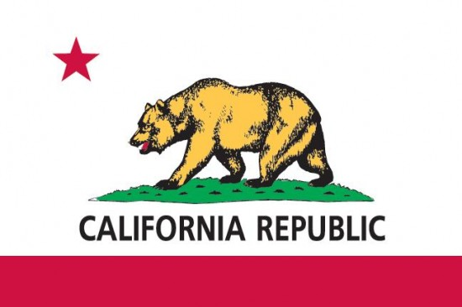
Bear Flag Republic
Gold Rush: _____________________________________________________________________________
_____________________________________________________________________________
_____________________________________________________________________________
_____________________________________________________________________________
_____________________________________________________________________________

Sectionalism and the Civil War
As the nation began to expand westward, and new states were being added, the issue of slavery became increasingly controversial. By 1849, the number of slave and free states was once again equal (15 and 15), but with the territories of California, Oregon and New Mexico waiting to be added the balance would once again be upset. As tension rose, the Southern states began to talk about secession and the formation of a separate Southern nation. In the North, the abolitionist movement continued to grow.
Compromise of 1850
Proposed by: _________________________________________________________________
Issue: _________________________________________________________________________________________________________________________________________________________________________________________________________________________________________________________________________________________________________________________________________________________________________________________________

Agreement reached: _________________________________________________________________________________________________________________________________________________________________________________________________________________________________________________________________________________________________________________________________________________________________________________________________

Fugitive Slave Act (1850)
Proposed by: _________________________________________________________________
Issue: _________________________________________________________________________________________________________________________________________________________________________________________________________________________________________________________________________________________________________________________________________________________________________________________________

Results: _________________________________________________________________________________________________________________________________________________________________________________________________________________________________________________________________________________________________________________________________________________________________________________________________

Slavery in the Territories
The issue of expansion of slavery into the territories was the cause of a sectional crisis in the mid-1850s. The railroad industry grew rapidly, and tracks were built across the continental US. As the railroads brought more Americans to the Midwest to farm, many of them brought their slaves. White settlers began to outnumber the Native Americans and tension increased between the whites, Indians and the older states to the East who became increasingly vocal regarding the issue of the expansion of slavery into the territories.

Kansas-Nebraska Act (1854)
Proposed by: _________________________________________________________________
Issue: _________________________________________________________________________________________________________________________________________________________________________________________________________________________________________________________________________________________________________________________________________________________________________________________________

Agreement reached: _________________________________________________________________________________________________________________________________________________________________________________________________________________________________________________________________________________________________________________________________________________________________________________________________

Pottawatomie Massacre (1855)
John Brown, a white abolitionist, believe himself to be an “instrument of God’s will” in the fight to end slavery. He had moved to Kansas to help in the struggle to keep it a “free state” and in a fit of abolitionist rage, he and his followers murdered 5 pro-slavery advocates and left their bodies out as a public warning to other supporters of slavery against coming to Kansas to fight for their cause. This led to various riots and conflicts throughout Kansas, earning it the nickname “Bleeding Kansas”.
Dred Scott Decision (1857)
Issue: _____________________________________________________________________________________________________________________________________________________________________________________________________________________________________________
Verdict and its Significance: _____________________________________________________________________________________________________________________________________________________________________________________________________________________________________________

Lincoln-Douglas Debates (1858)
Abraham Lincoln: ____________________________________________________________________________________________________________________________________________________________
Stephen Douglas: ____________________________________________________________________________________________________________________________________________________________
Lincoln’s Position on Slavery: ________________________________________________________________________________________________________________________________________________________________________________________________________________________________________________________________________________________________________________________

John Brown’s Raid (1859)
John Brown, the same abolitionist from Kansas, made an attempt to rob the arsenal at Harper’s Ferry, Virginia in an effort to arm Southern slaves in the area and lead a violent slave revolt. His plan was discovered and he was captured by US troops (under the command of Robert E. Lee) and was eventually hanged. Brown was seen as a hero in the North, but convinced white Southerners that they were not safe and that the North Republican government was plotting against them.
Election of Abraham Lincoln (1860)
Candidates: _____________________________________________________________________________________________________________________________________________________________________________________________________________________________________________
Election Results and their Significance: _____________________________________________________________________________________________________________________________________________________________________________________________________________________________________________

